Discover Shortest Path Project creation:

Step1: created project as you given in the docs.

* Source code with a maven build script
  + The project will be built and executed onsite.
  + The build script must have the following details:
    - groupId to be za.co.discovery.assignment
    - artefactId :ravinder
    - version to be 1.0.0_SNAPSHOT

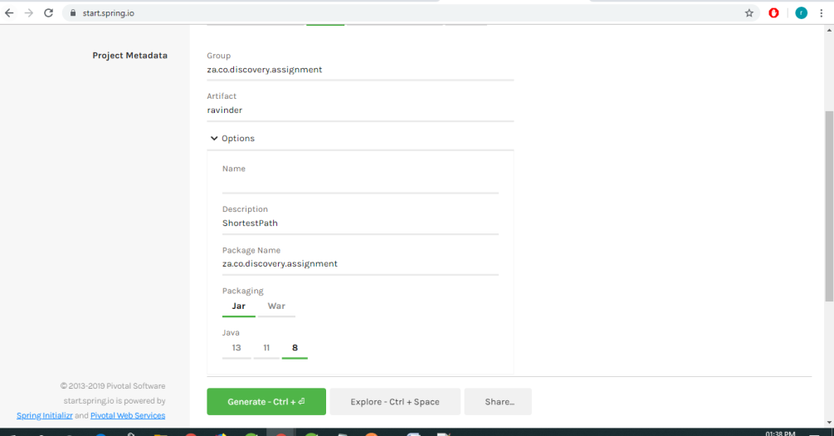

Step3: import the project

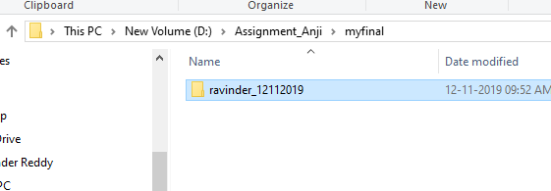

Step4:

Restful services end points

<http://localhost:8014/planets>

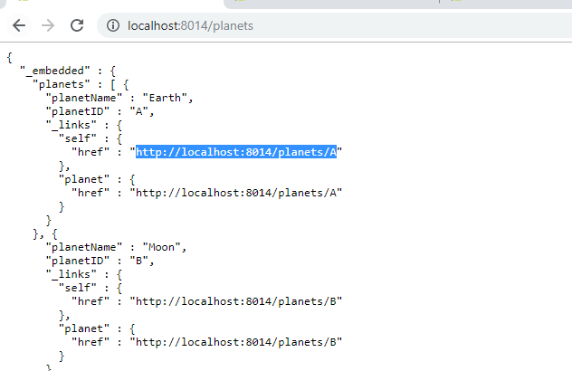

if you want to find the particular planet use below api

<http://localhost:8014/planets/A>

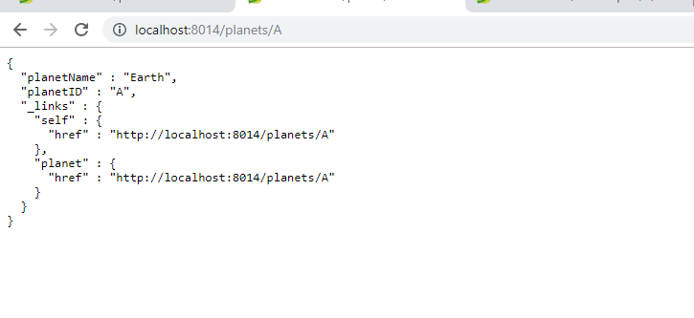

<http://localhost:8013/shortestpath/A/Z>

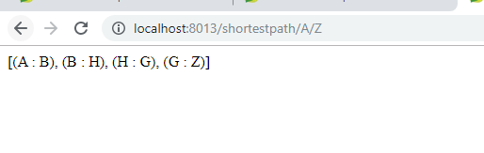

Add the new record into the DB using post man:

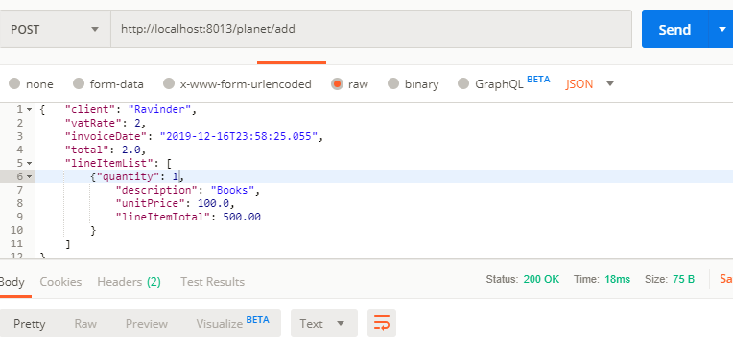

<http://localhost:8014/routes>

For Business Logic:

ShortestPathService.java

-Contains the DijkstraAlgorithm business logic

Context load the xls data class:

DataLoaderImpl.JAVA

-Waits for the Spring Boot context to start than reads the XLS data file

UI: Angular 6 I need to implement for All service for CRUD operation